Phillips Curve, Loanable Funds and Savings, Comparative Advantage
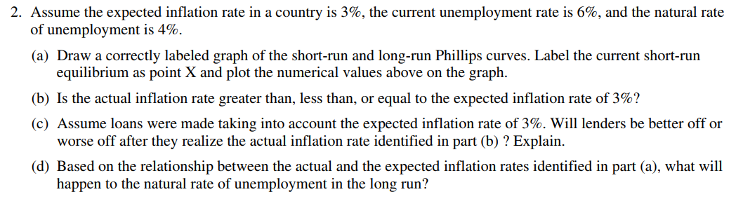

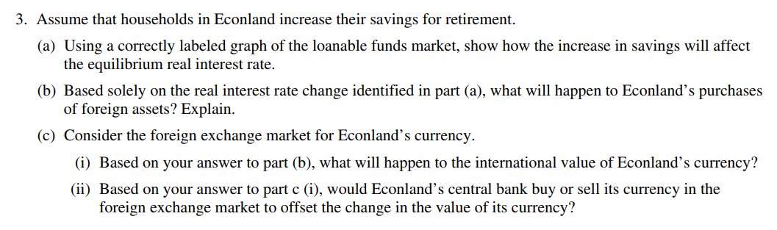

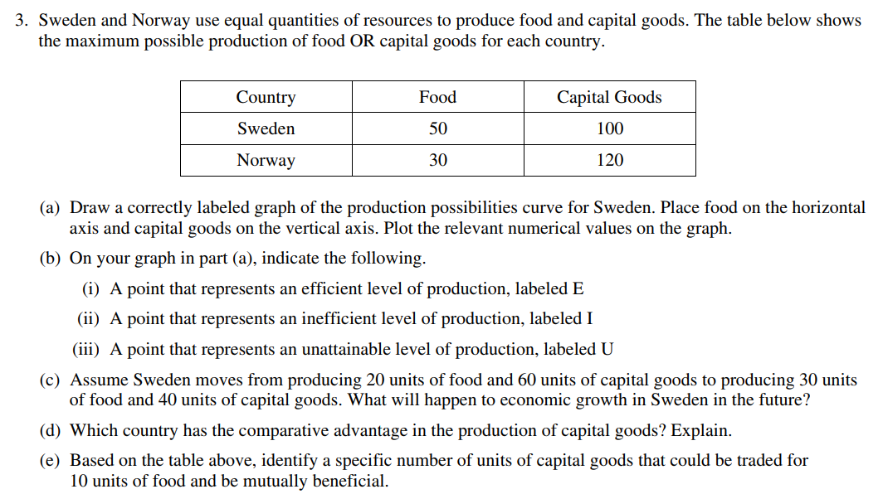

- Use the table to answer the following questions.
 | Greece | Germany
Cars | 5 workers | 2 workers
Olives | 4 workers | 5 workers
- Which country has absolute advantage in cars? In olives?
- Which country has comparative advantage in cars? In olives?
- What is the range of prices for cars that would be acceptable?
- What is a price that would be acceptable for both countries?
- Would the price of 1 car for 1 ton of olives be an acceptable price to allow for trade?

